***CSA-1006:-SOFTWARE ENGINEERING WITH DATA ANALYTICS***

***Name: N.jagan mohan Reddy***

***Reg.no: 192110673***

**1Q. Draw a USE-CASE diagram for Online Voting System using CASE tools**

***Aim:*** To draw a use case diagram for online voting system using case tools.

***Software Used:*** Umbrello.

***Diagram:***

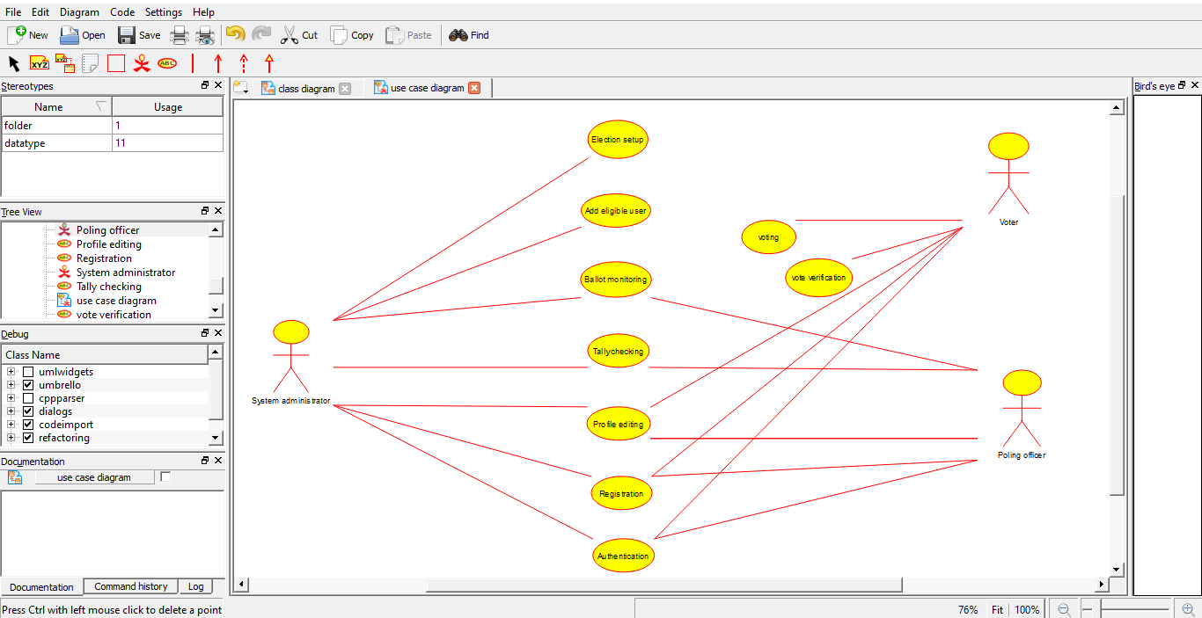

N.Jagan

Regno:192110673

**Result:** Drawing a use case diagram for online voting system was completed successfully.

**2Q. Draw a USE-CASE diagram for Library Management System using CASE tools.**

**Aim:** To draw a use case diagram for library management system using case tools.

**Software Used:** Umbrello.

**Diagram:**

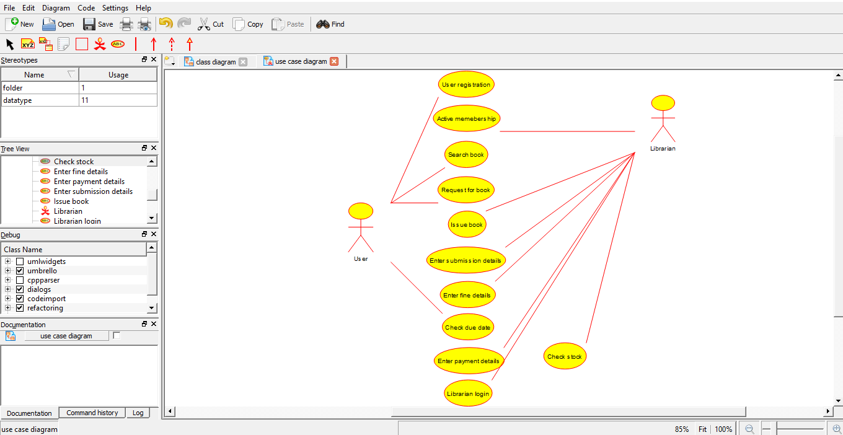

N.jagan

Regno:192110673

**Result:** Drawing a use case diagram for library management system was completed successfully.

**3Q. Draw and validate the flowchart to compute the quotient and remainder.**

**Aim:** To draw and validate the flowchart to compute the quotient and remainder.

**Software Used:** Raptor.

**Diagram:**

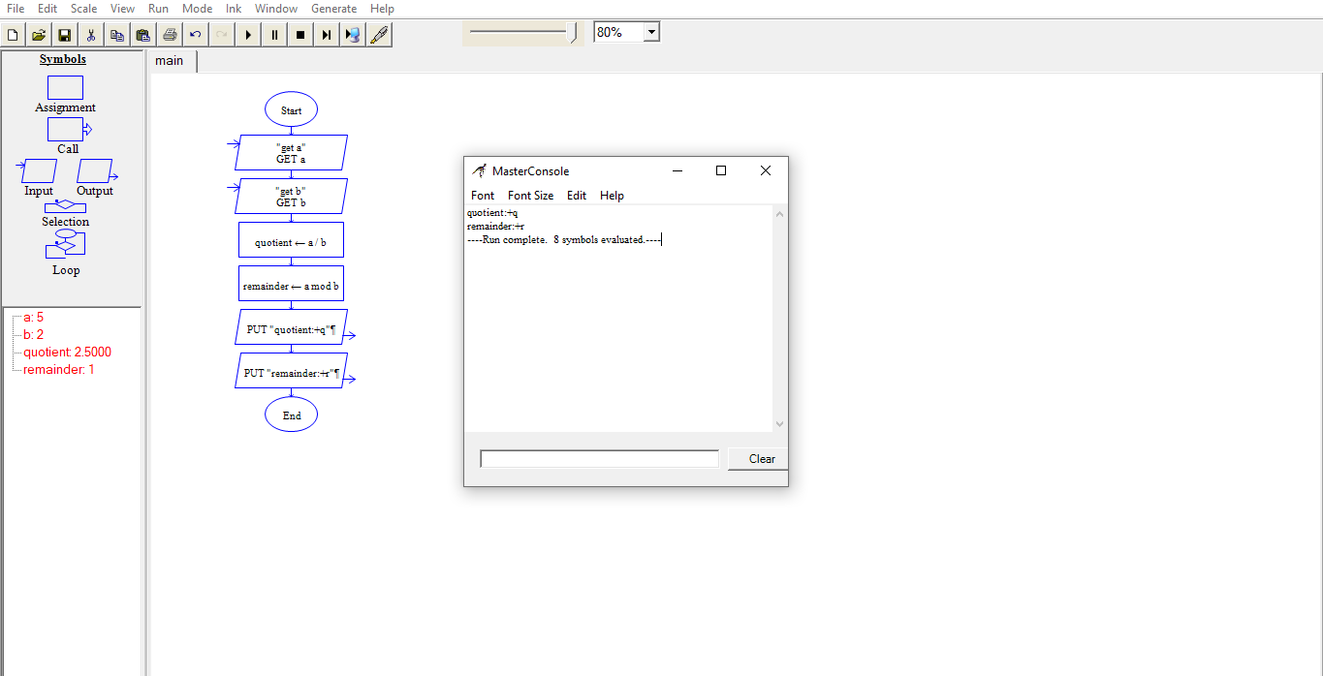

N.jagan

Regno: 192110673

**Result:** Flowchart to compute the quotient and remainder was completed and output verified.

**4Q. Draw a USE-CASE diagram for Online Shopping system using CASE tools.**

**Aim:** To draw a use case diagram for online shopping system.

**Software Used:** Umbrello.

**Diagram:**

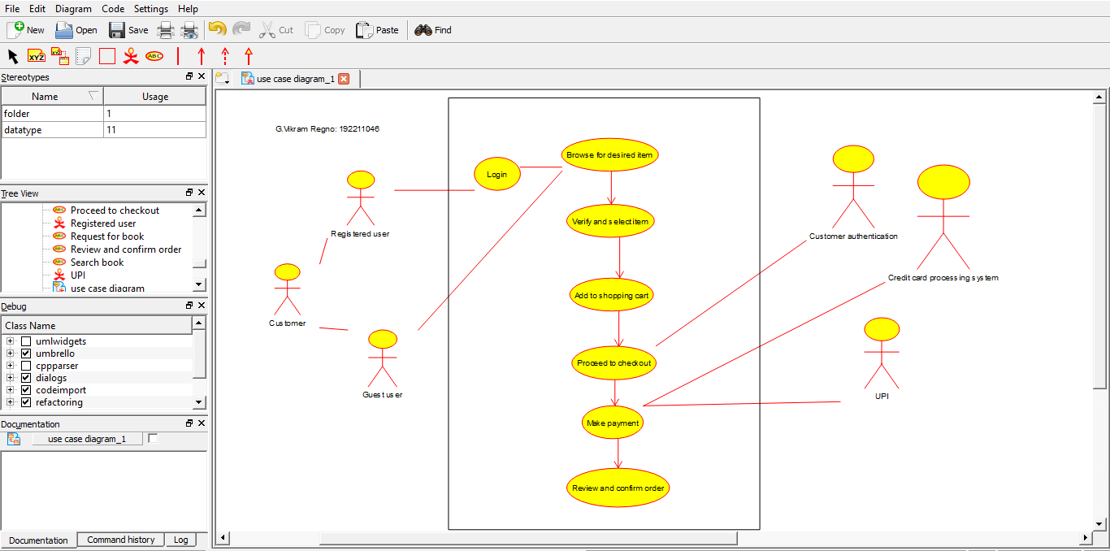

**Result:** Drawing of use case diagram for online shopping voting system was successfully completed.

**5Q. Draw a USE-CASE diagram for Online Railway Reservation System using CASE tools.**

**Aim:** To draw a use case diagram for online railway reservation system.

**Software Used:** Umbrello.

**Diagram:**

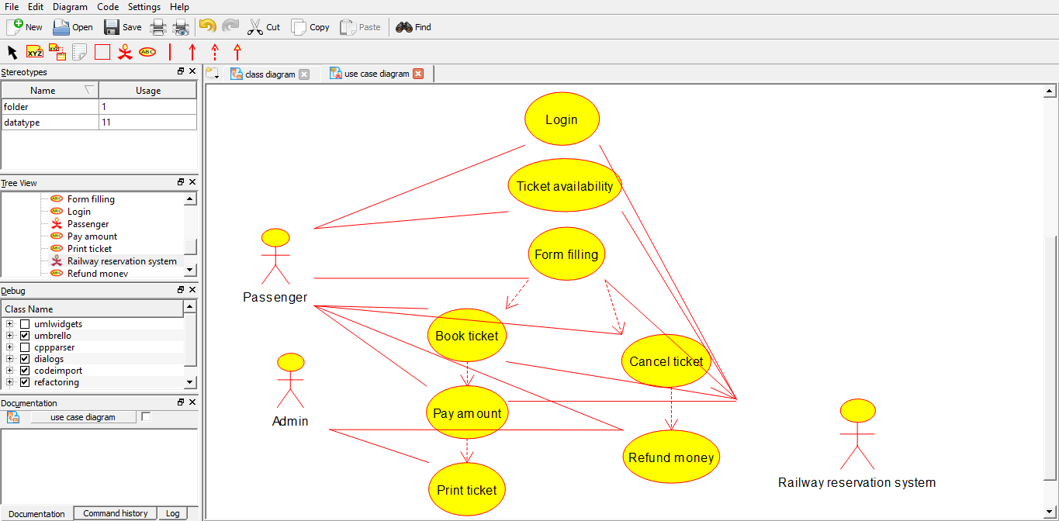

N.jagan

Regno:192110673

**Result:** Use case diagram for online railway reservation system was successfully completed.

**6Q. Draw a USE-CASE diagram for Hospital Management System using CASE tools.**

**Aim:** To draw a use case diagram for hospital management system.

**Software Used:** Umbrello.

**Diagram:**

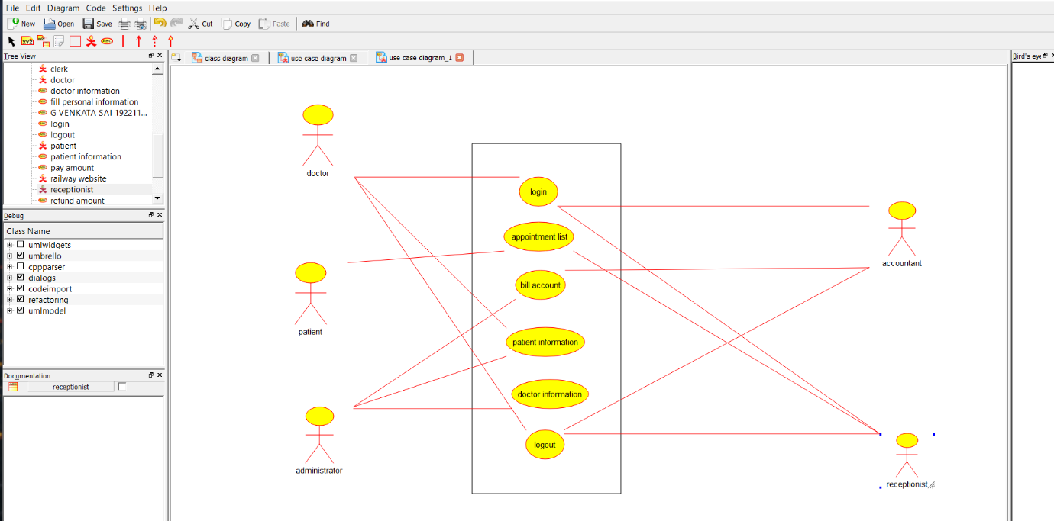

N.jagan

Regno: 192110673

**Result:** Use case diagram for hospital management system was successfully completed.

**7Q. Draw a USE-CASE diagram for ATM System using CASE tools.**

**Aim:** To draw a use case diagram for ATM system.

**Software Used:** Umbrello.

**Diagram:**

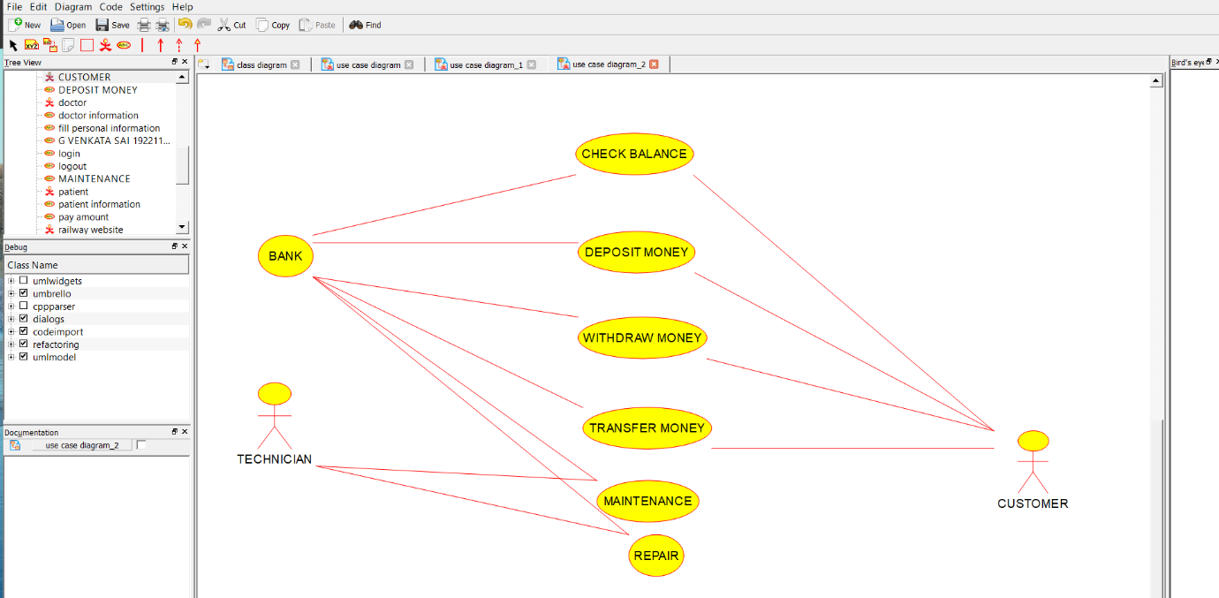

N.jagan

Regno: 192110673

**Result:** Use case diagram for ATM system was completed successfully.

**8Q. Draw a USE-CASE diagram for Online college management System using CASE tools.**

**Aim:** To draw a use case diagram for online college management system.

**Software Used:** Umbrello.

**Diagram:**

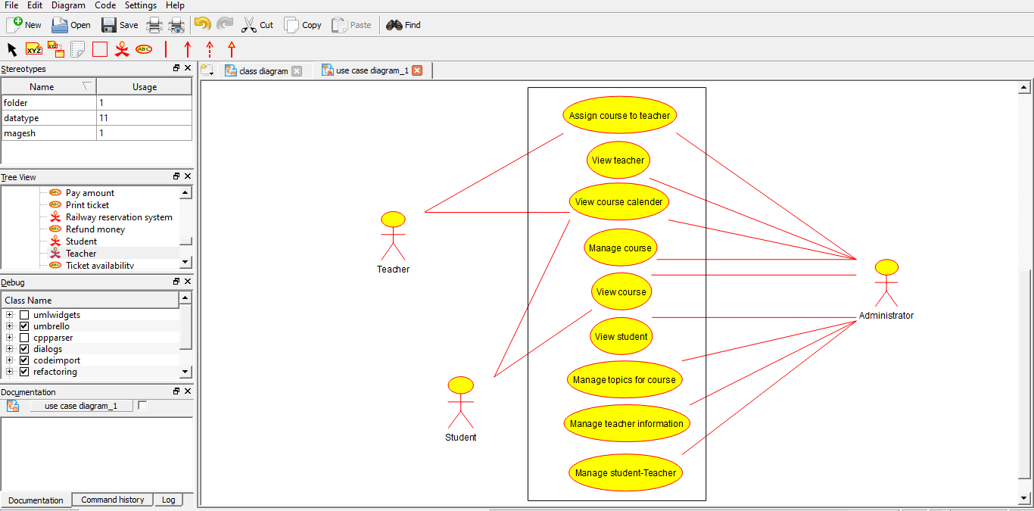

N.jagan

Regno:192110673

**Result:** Use case diagram for online college management system was successfully completed.

**9Q. Draw a USE-CASE diagram for Online Airline Reservation System using CASE tools.**

**Aim:** To draw a use case diagram for online airline reservation system.

**Software Used:** Umbrello

**Diagram:**

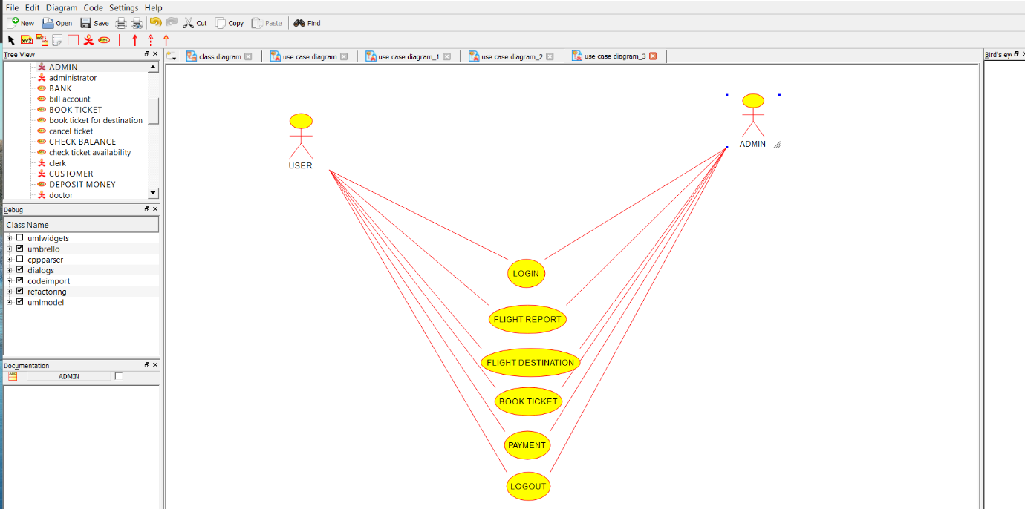

N.jagan

Regno: 192110673

**Result:** Use case diagram for online airline reservation system was successfully completed.

**10Q. Draw a Class diagram for Online Airline Reservation System**

**using CASE tools.**

**Aim:** To draw a class diagram for online airline reservation system.

**Software Used:** Umbrello.

**Diagram:**

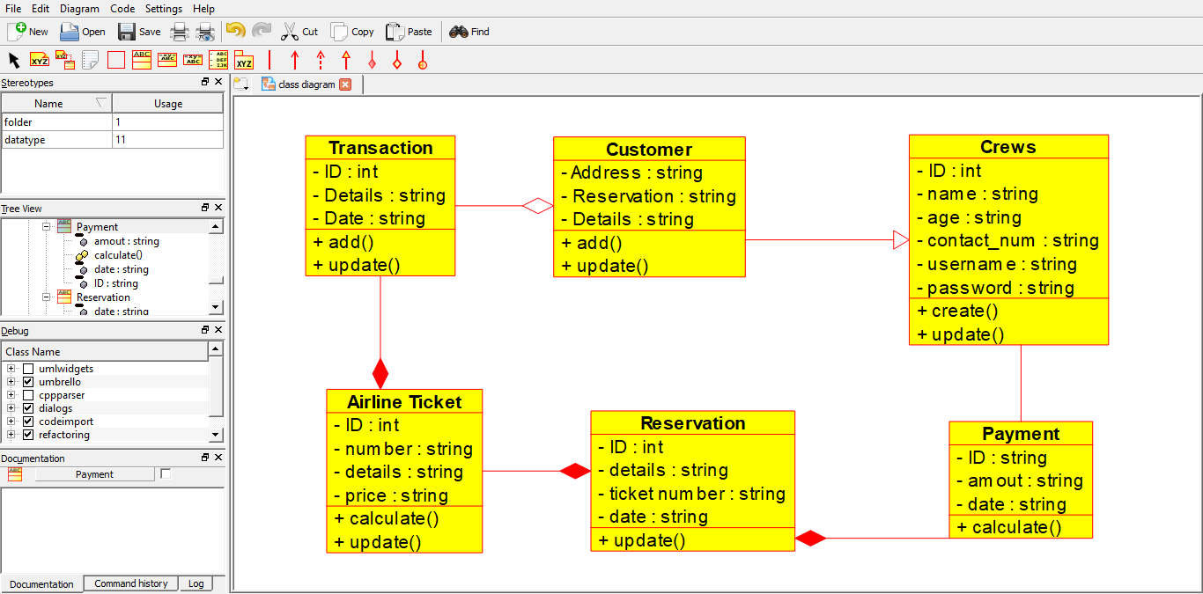

N.jagan

Regno:192110673

**Result:** Class diagram for online airline reservation system was successfully completed.

**11Q. Draw a Class diagram for Online Voting System using CASE tools**

**Aim:** To draw a class diagram for online voting system.

**Software Used:** Umbrello.

**Diagram:**

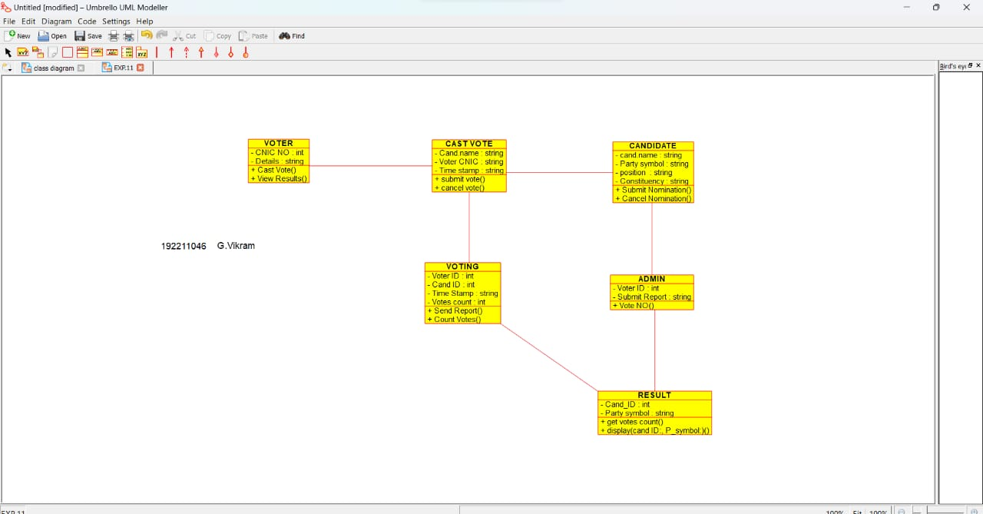

N.Jagan

192110673

**Result:** Class diagram for online voting system was successfully completed.

**12Q. Draw a Class diagram for Library Management System using CASE tools.**

**Aim:** To draw a class diagram for library management system.

**Software Used:** Umbrello.

**Diagram:**

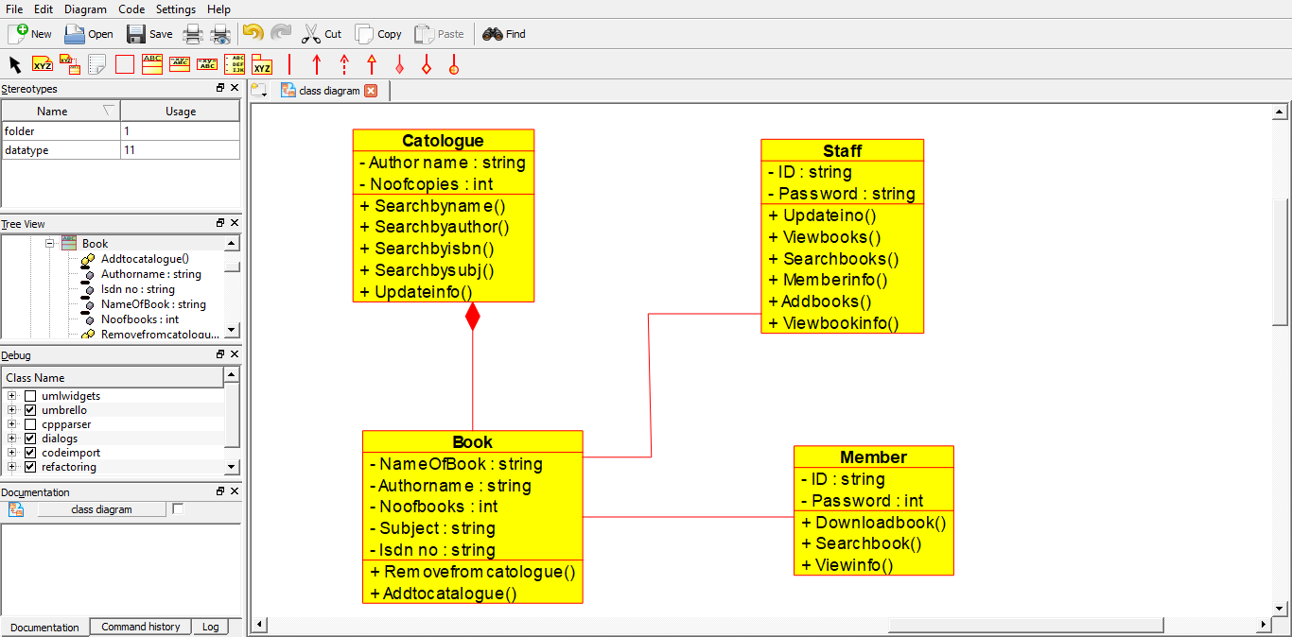

N.jagan

Regno: 192110673

**Result:** Class diagram for library management system was successfully completed.

**13. Draw an Activity diagram for Online voting system using CASE tools.**

**Aim:** To draw an activity diagram for online voting system using case tools.

**Software used:** Umbrello.

**Diagram:**

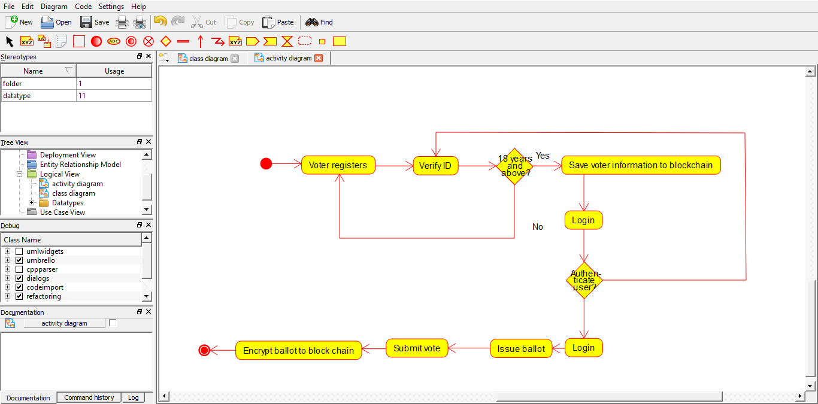

N.jagan

Regno: 192110673

**Result:** Activity diagram for online voting system was completed successfully.

**14Q. Draw an Activity diagram for Library management System using CASE tools.**

**Aim:** To draw an activity diagram for library management system.

**Software used:** Umbrello.

**Diagram:**

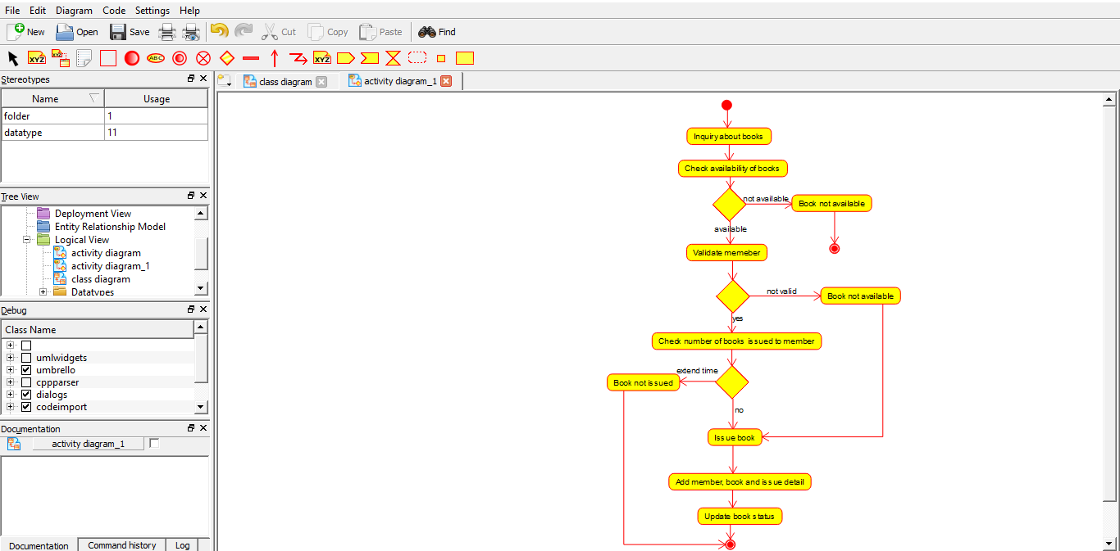

N.jagan

Regno: 192110673

**Result:** Activity diagram for library management system was successfully completed.

**15Q. Draw an Activity diagram for Online Shopping System using CASE tools.**

**Aim:** To draw an activity diagram for online shopping system.

**Software used:** Umbrello.

**Diagram:**

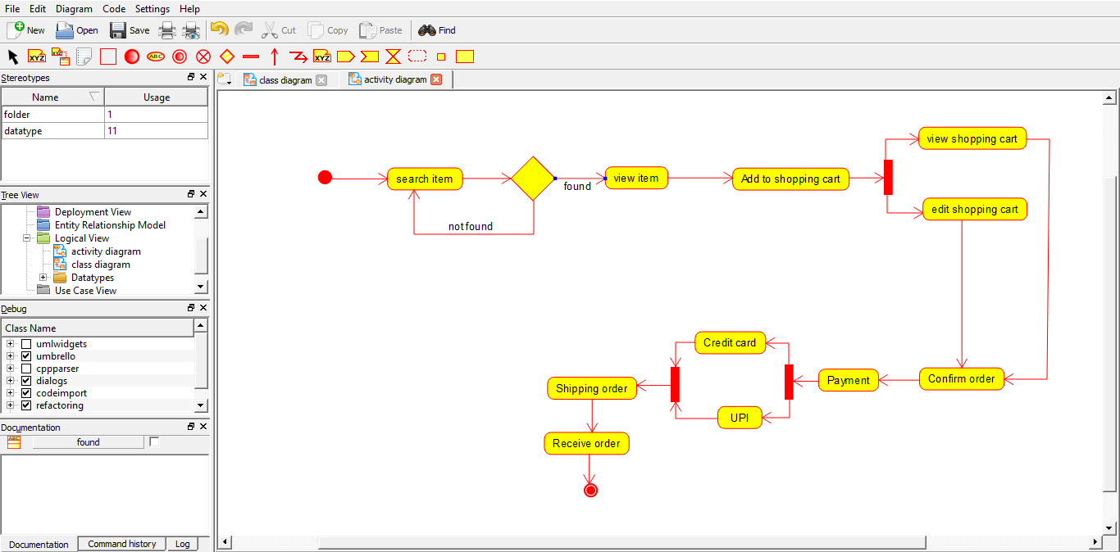

N.jagan

Regno: 192110673

**Result:** Activity diagram for online shopping system was successfully completed.

**16Q. Draw an activity diagram for online railway reservation System using CASE tools.**

**Aim:** To draw an activity diagram for online railway reservation system

**Software used:** Umbrello.

**Diagram:**

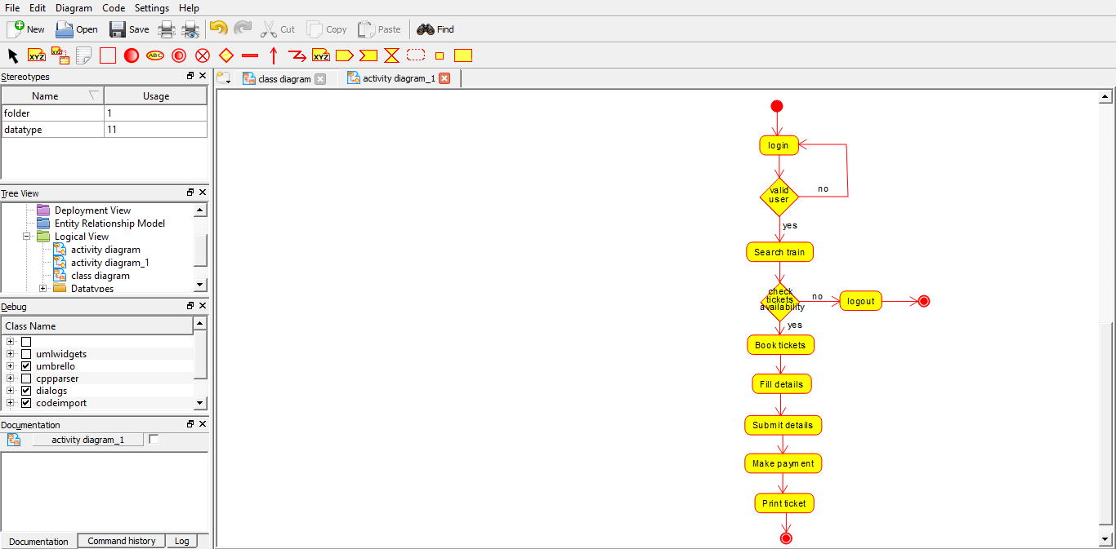

N.jagan

Regno: 192110673

**Result:** Activity diagram for online railway reservation system was successfully completed.

**17Q. Draw an activity diagram for hospital management system using CASE tools.**

**Aim:** To draw an activity diagram for hospital management system.

**Software used:** Umbrello.

**Diagram:**

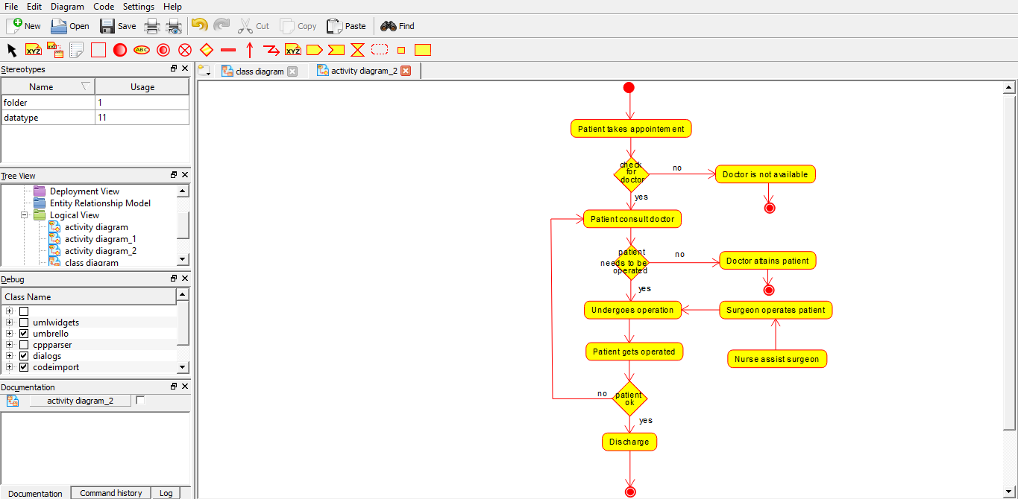

N.jagan

Regno: 192110673

**Result:** Activity diagram for hospital management system was successfully completed.

**18Q. Using Raptor- Draw the flowchart to check whether the given number is a palindrome or not.**

**Aim:** To draw the flowchart to check whether the given number is a palindrome or not.

**Software used:** Raptor

**Diagram:**

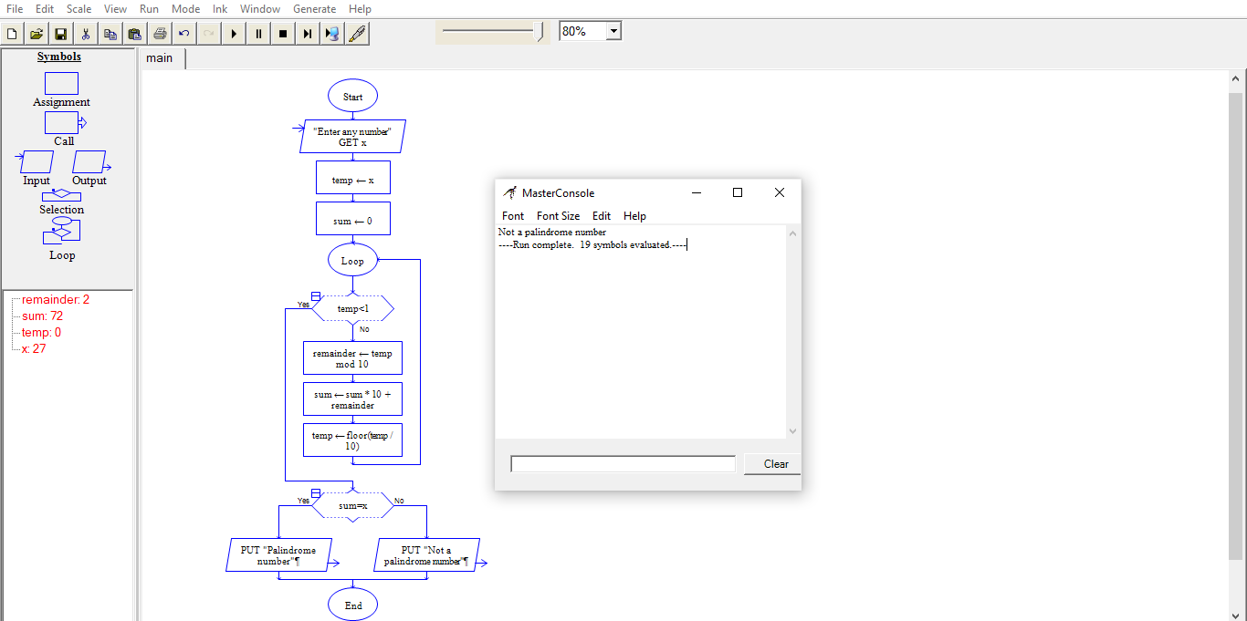

N.jagan

Regno: 192110673

**Result:** Flowchart to check whether the given number is palindrome or not was completed and output verified.

**19Q.Using Raptor – Draw and validate the flowchart to swap two characters.**

***AIM:***

To draw and validate the flowchart to swap two characters.

***SOFTWARE USED:***

**Raptor**

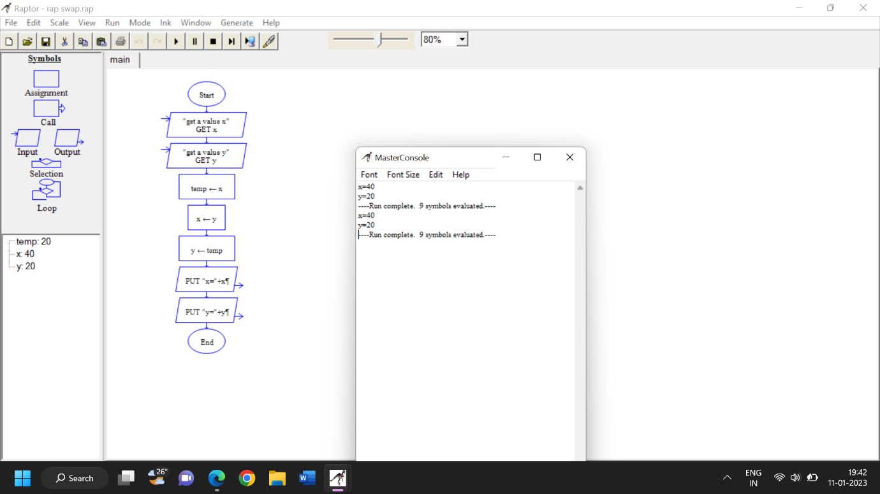

***RESULT:***

To draw and validate the flowchart to swap two characters was successfully completed.

20Q.Using Raptor – Draw the flowchart to display the length of the string.

***AIM:***

To draw and validate the flowchart to display the length of the string.

***SOFTWARE USED:***

**Raptor**

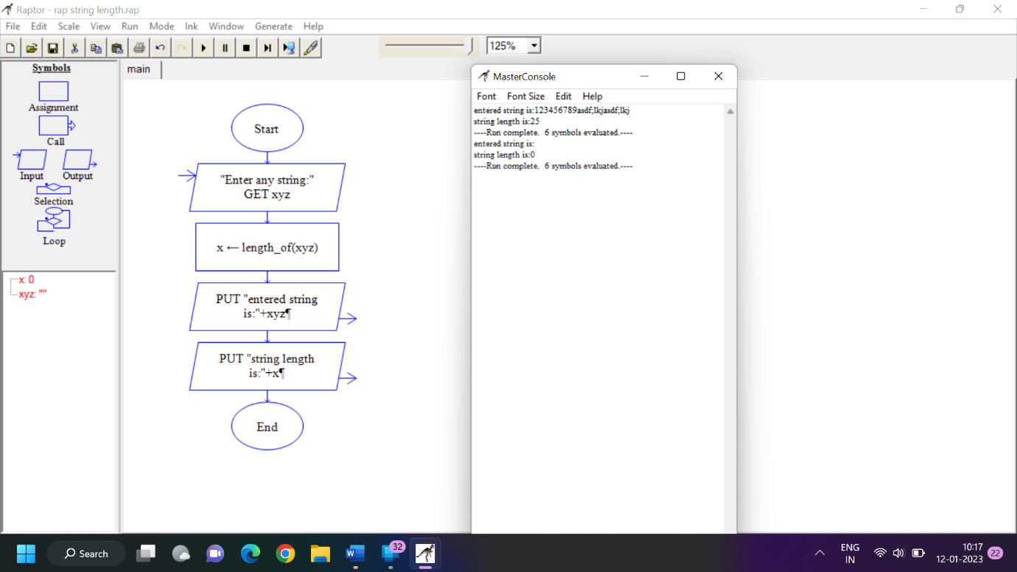

***RESULT:***

To draw and validate the flowchart to display the length of the string was successfully completed.

**21Q. Using Raptor - Draw the flowchart to find whether the given number is prime or not.**

**Aim:** To draw the flowchart to find whether the given number is prime or not.

**Software used:** Raptor.

**Diagram:**

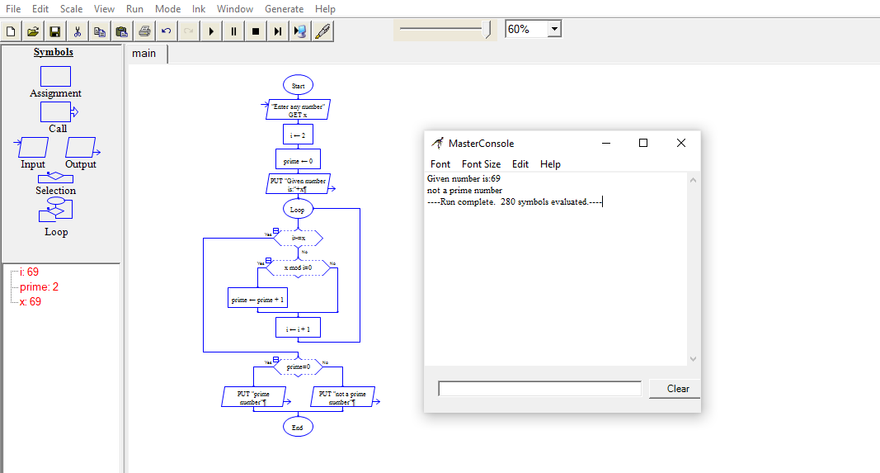

n.jagan

Regno: 192110673

**Result:** Flowchart to find whether the given number is prime or not was completed and output verified.

**22Q. Find the cyclomatic complexity for a graph having number of edges as 17, number of nodes as 13 and the predicate nodes are 5**

**Aim:** To get the cyclomatic complexity for a graph.

**Diagram:**

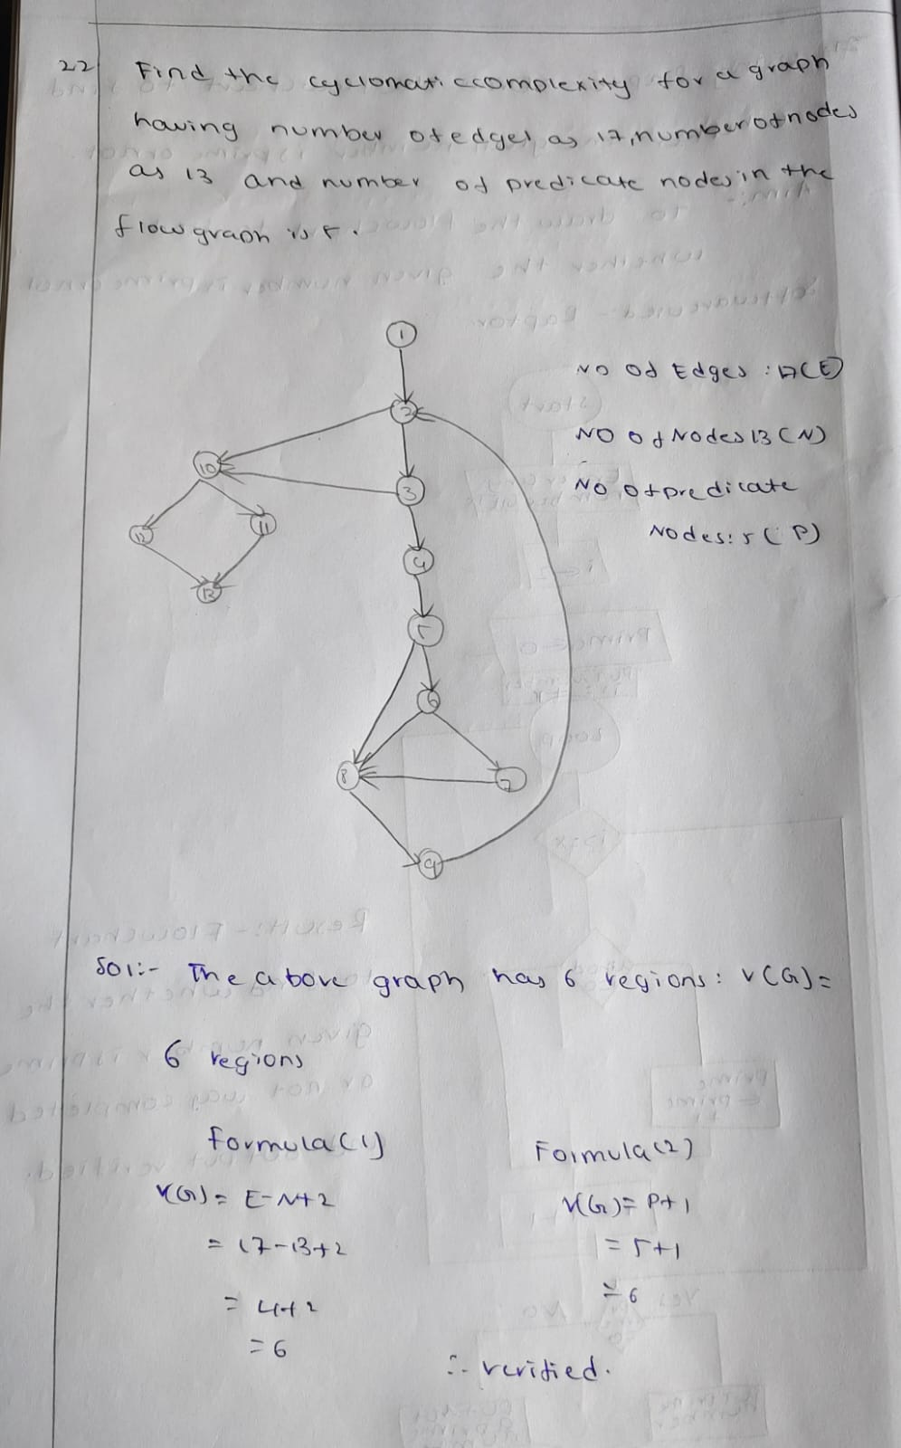

N.jagan

Regno: 192110673

**23Q. Draw an activity diagram for an automated online banking system.**

**Aim:** To draw the activity diagram for an automated online banking system.

**Software used:** Umbrello

**Diagram:**

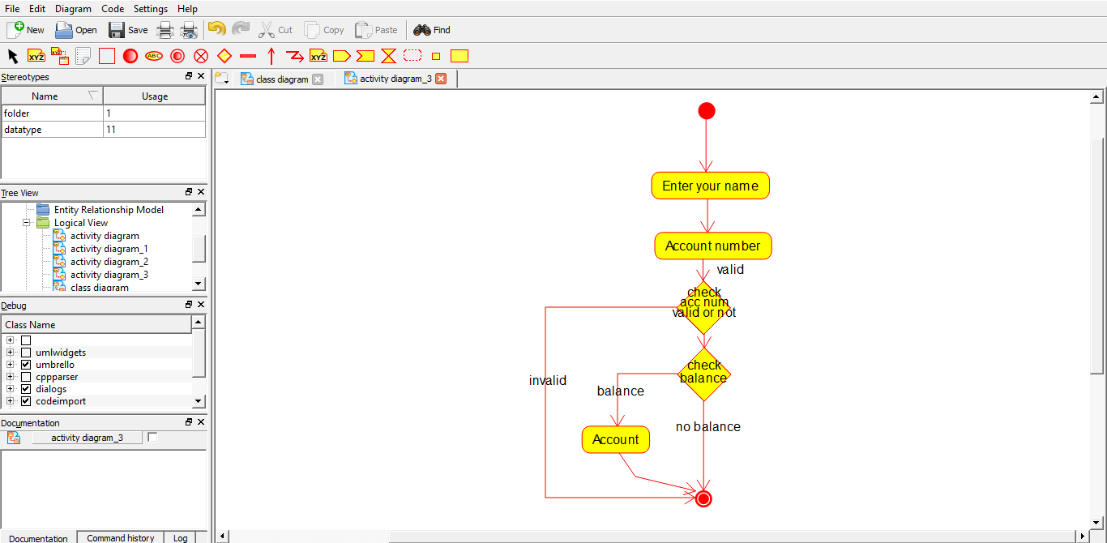

N.jagan

Regno: 192110673

**Result:** Activity diagram for an automated online banking system was completed successfully.

**24Q. Develop an activity diagram for an e-library online public access catalogue.**

**Aim:** To draw an activity diagram for an e-library online public access cataologue.

**Software used:** Umbrello

**Diagram:** 

N.jagan

Regno: 192110673

**Result:** Activity diagram for an e-library online public access catalogue was completed successfully.

**25Q. Draw a Class diagram for an e-library online public access catalogue.**

**Aim:** To draw the class diagram for an e-library online public access catalogue.

**Software used:** Umbrello

**Diagram:**

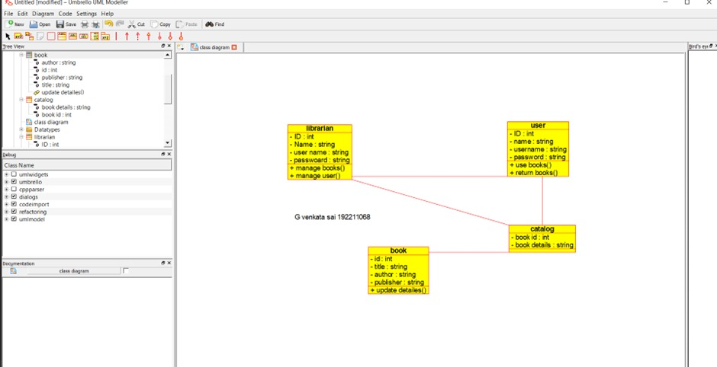

N.jagan

Reg no: 192110673

**Result:** Class diagram for an e-library online public access catalogue is successfully completed.

**26Q.Draw a use case diagram for a restaurant system. The activity of the restaurant system is listed below. Receive the customer food orders, serve the customer with their ordered food, collect payment from customers, store customer payment details, order raw materials for food products, pay for raw materials and pay for labour.**

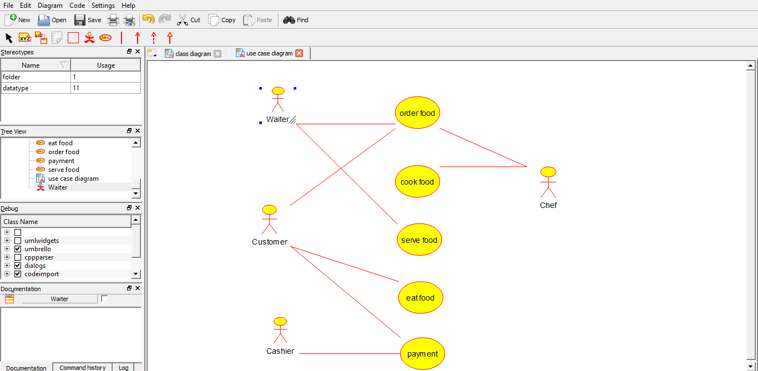

N.jagan

Regno: 192110673

**27Q. Draw a class diagram for a restaurant system. The restaurant system is listed below. Receive the customer food orders, serve the customer with their ordered food, collect payment from customers, store customer payment details, order raw materials for food products, pay for raw materials and pay for labour.**

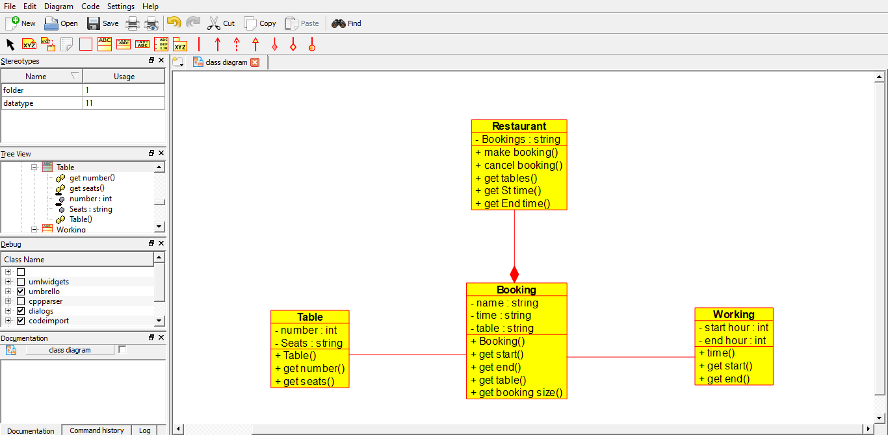

N.jagan

Regno: 192110673

**28Q.Make a class diagram to model for a quiz system. The user can request a quiz system. A user can request a quiz for the system. The system picks a set of questions from its database, and composes them together to make a quiz. It rates the user’s answers and gives hits if the user requests it. In addition to users, we also have helpers who provide questions and hints. And administrators who must certify questions to make sure they are not too big, and that they are correct.**

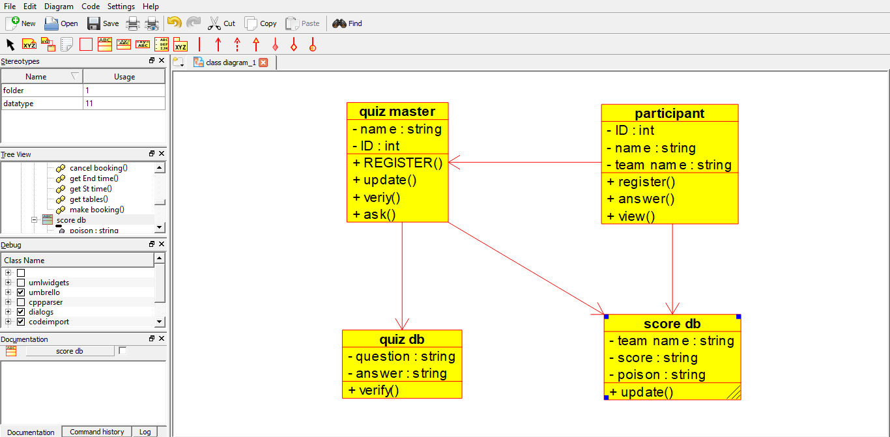

N.jagan

Regno: 192110673

**29Q.Draw a use case diagram to model for a quiz system. A user can request a quiz system. A user can request a quiz for the system. The system picks a set of questions from its database, and composes them together to make a quiz. It rates the user’s answers and gives hits if the user requests it. In addition to users, we also have helpers who provide questions and hints. And administrators who must certify questions to make sure they are not too trival, and that they are correct.**

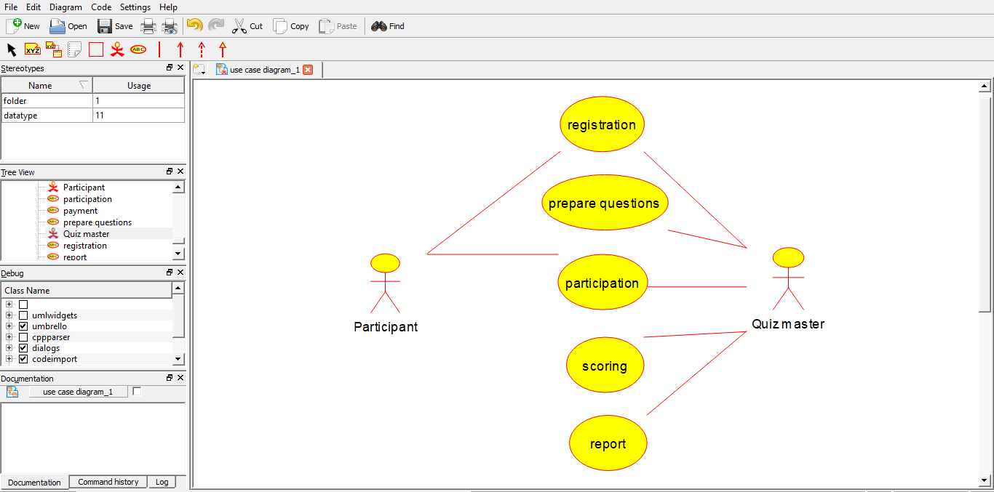

N.jagan

Regno: 192110673

**30Q.Using Raptor-Draw and validate the flow chart to calculate factorial of a number.**

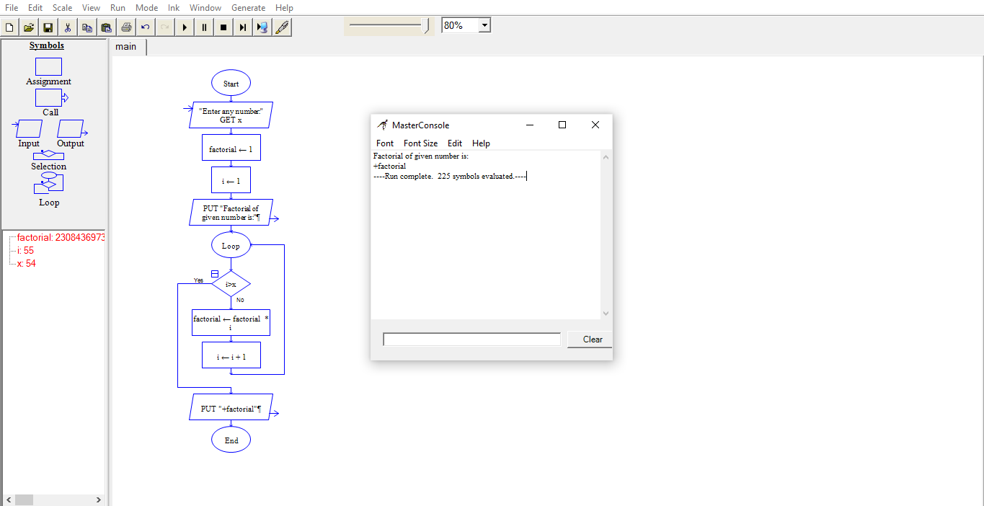

N.jagan

Regno: 192110673

**31. Using Raptor – Draw and validate the flowchart to find odd series of the given number.**

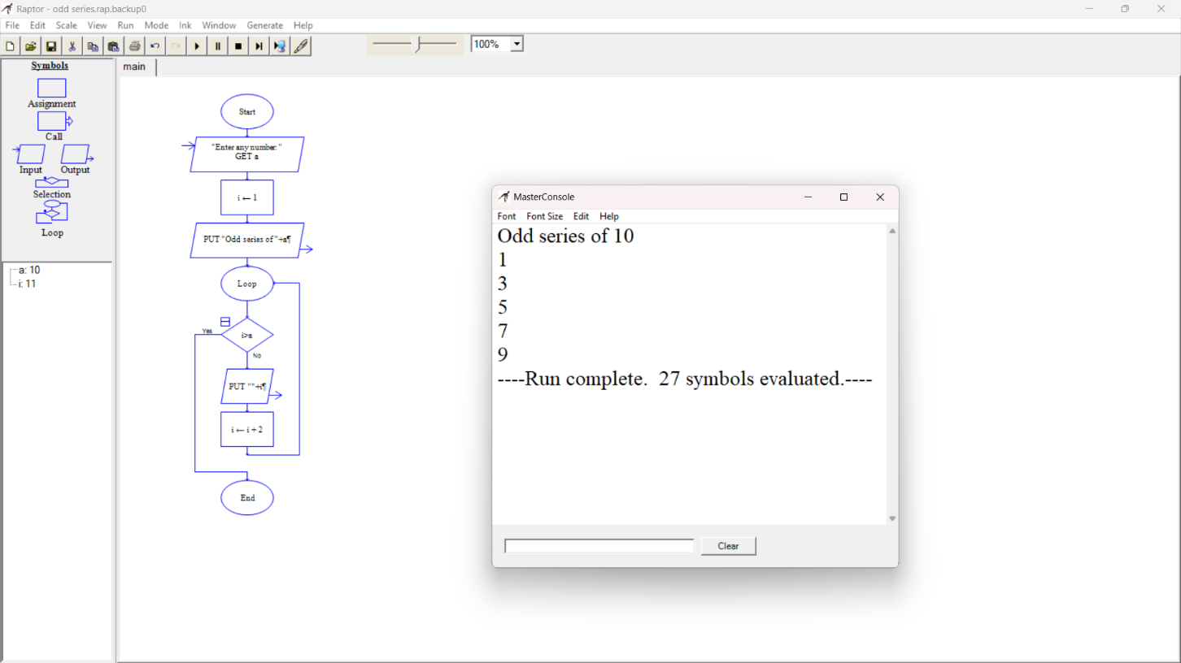

N.jagan

Regno: 192110673

**32Q.Using Raptor-Draw and validate the flow chart to display the reverse of the string.**

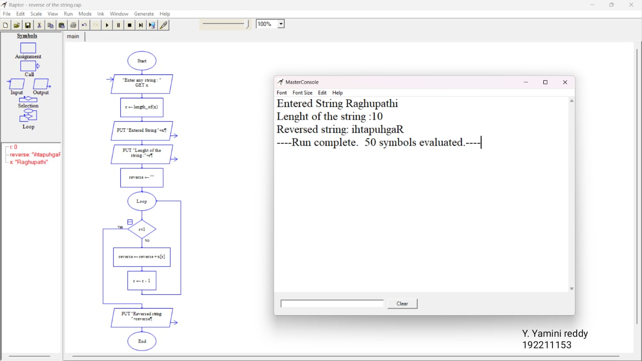

N.jagan

Regno: 192110673

**33Q. Using Raptor-Draw and validate the flow chart to find largest of n Numbers.**

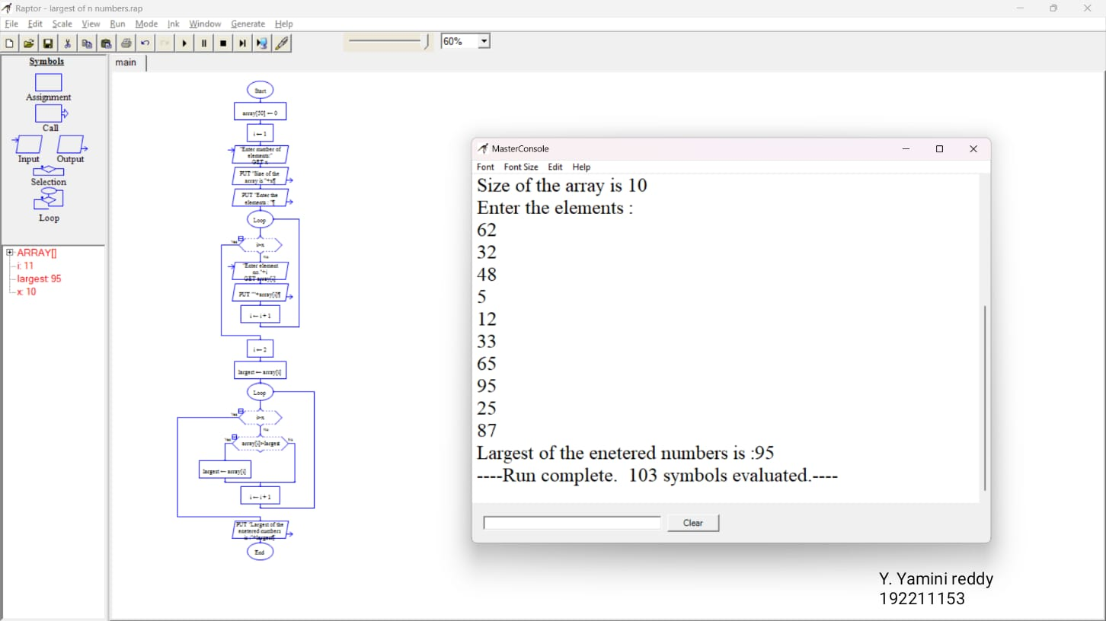

N.jagan

Regno: 192110673

**34Q.Find cyclomatic complexity for a graph having number of edges as 20, number of nodes as 15 and number of predicate nodes in the flow graph as 4.**

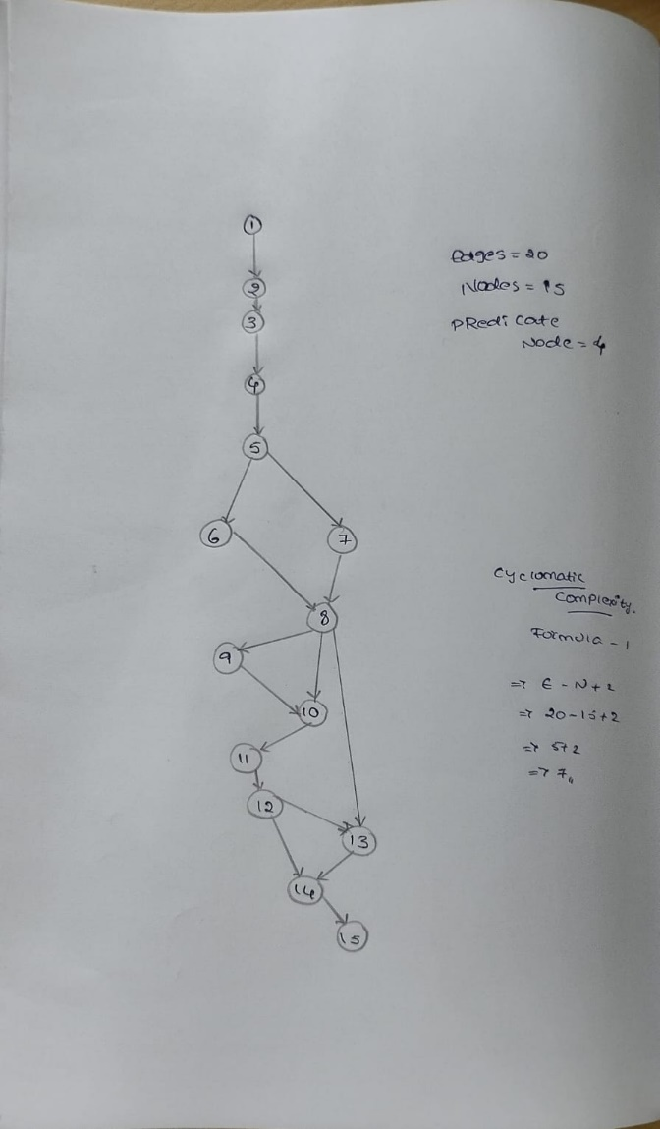

N.jagan

Regno: 192110673

**35Q. Using Raptor- Draw and validate the flowchart to calculate Fibonacci series.**

**Aim:** To draw and validate the flowchart to calculate Fibonacci series.

**Software used:** Raptor.

**Diagram:**

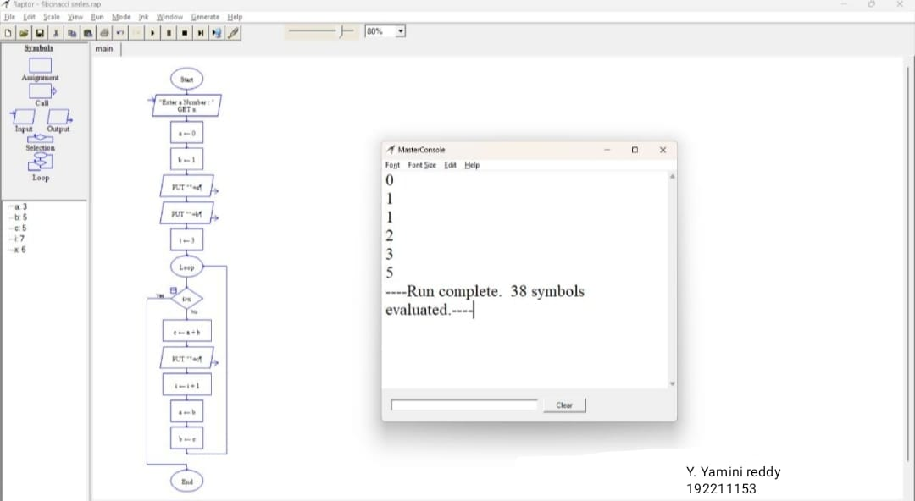

njagan

Regno: 192110673

**Result:** Flowchart to calculate Fibonacci series was completed and output verified

**36Q.using Raptor-Draw the flowchart to find smallest of n Numbers.**

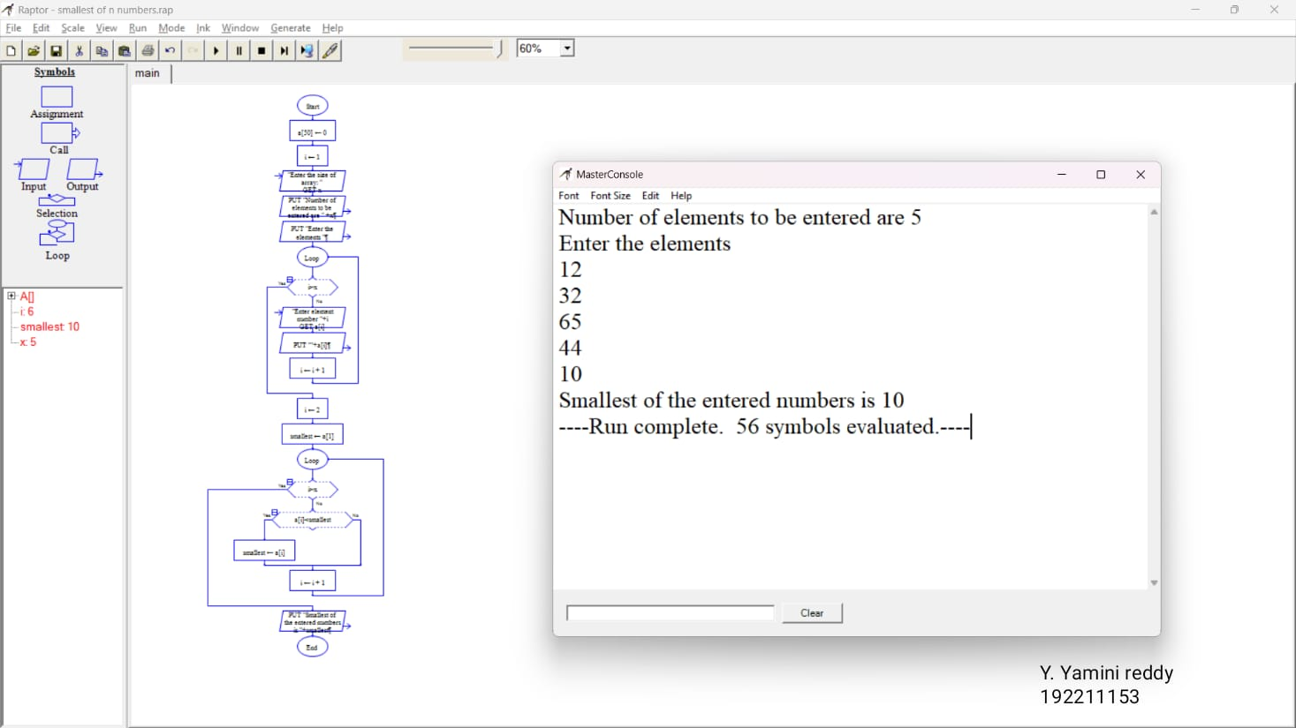

N.jagan

Regno: 192110673

**37Q.Draw use case diagram for E-wallet online prepaid account.**

**Aim:** To draw a use case diagram for E-wallet online prepaid account

**Software used:** umbrello

**Diagram:**

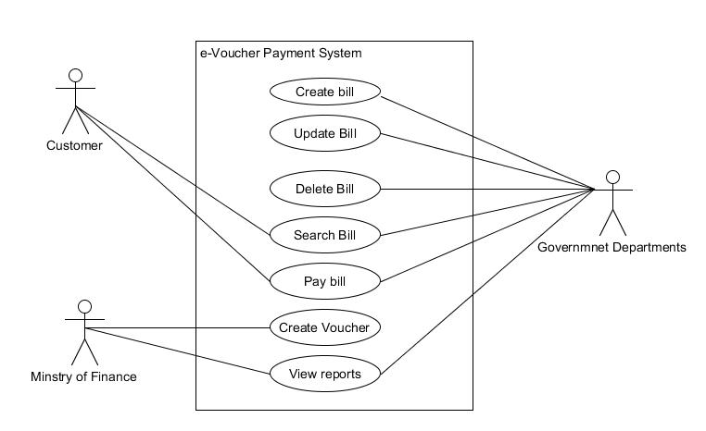

N.jagan

Regno: 192110673

**Result:** use case diagram for E-wallet online prepaid account was completed successfully.

**38Q. Draw a class diagram for online security management system**

**Aim:** To draw a class diagram for online security management system

**Software used:** umbrello

**Diagram:**

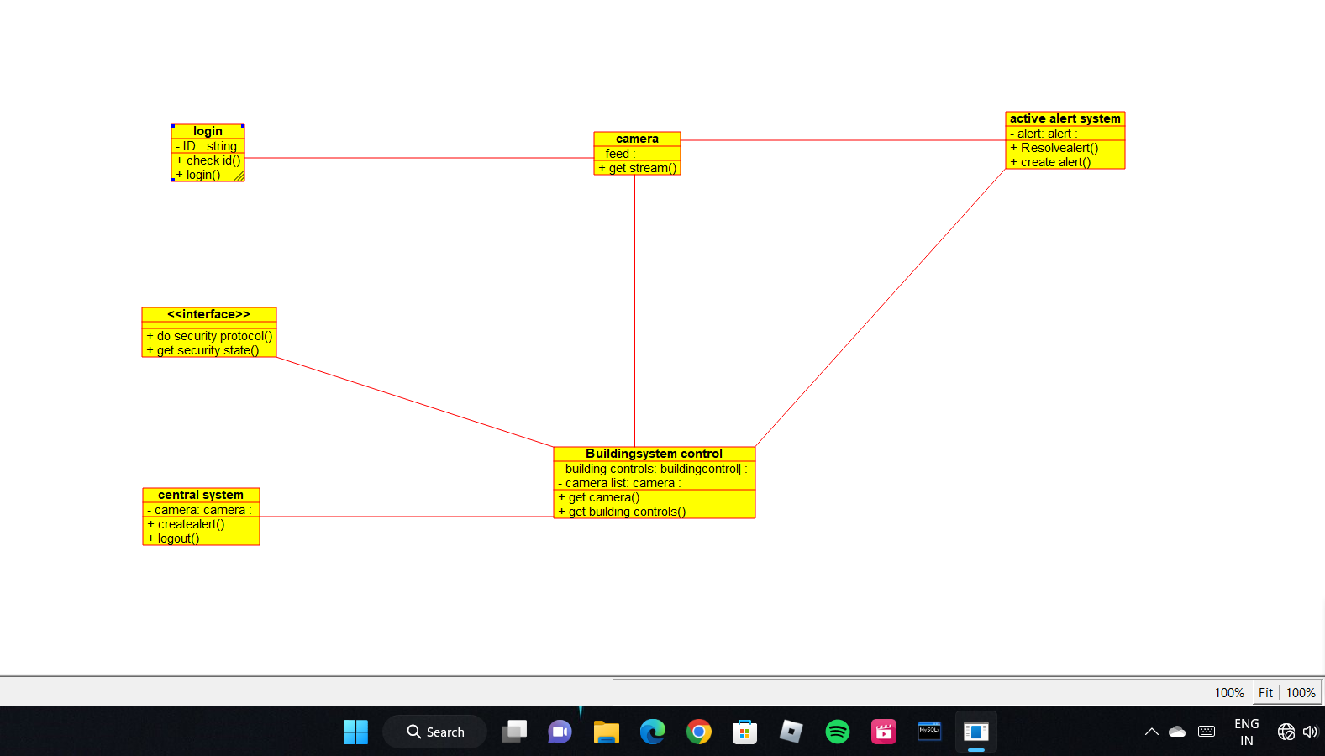

N.jagan

Regno: 192110673

**Result:** Class diagram for online security management system was successfully completed

**39Q.Draw a Class diagram for Online Voting System using CASE tools**

**Aim:** To draw a class diagram for online voting system.

**Software Used:** Umbrello.

**Diagram:**

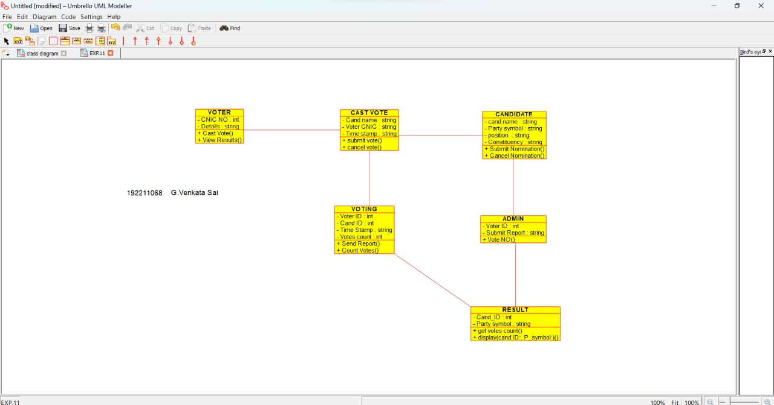

N.jagan

192110673

**Result:** Class diagram for online voting system was successfully completed.

**40Q. Using Raptor- Draw the flowchart to check whether the given number is a palindrome or not.**

**Aim:** To draw the flowchart to check whether the given number is a palindrome or not.

**Software used:** Raptor.

**Diagram:**

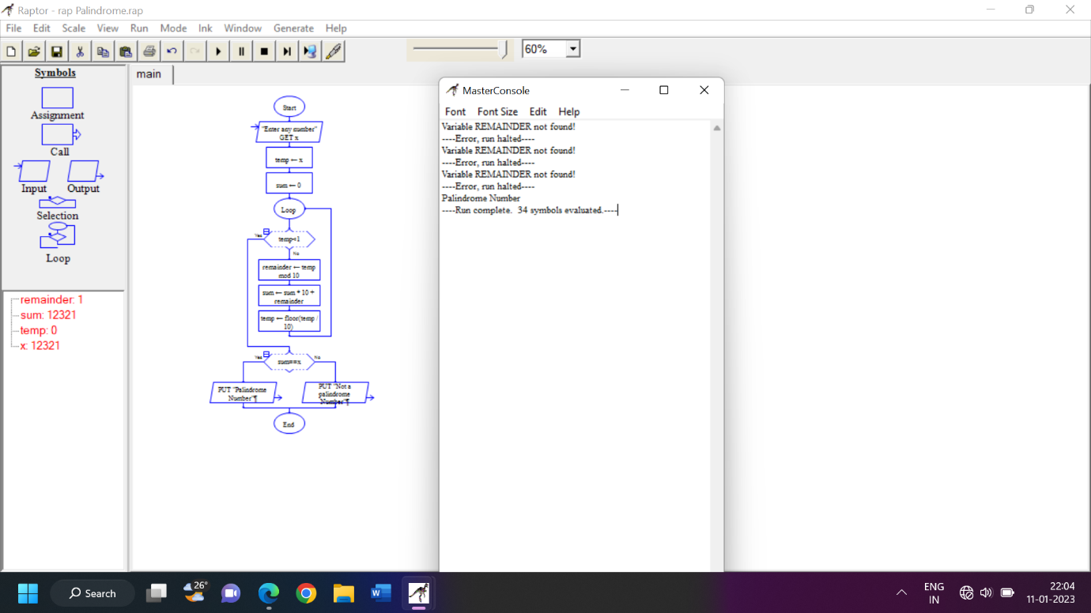

N.jagan

Regno: 192110673

**Result:** Flowchart to check whether the given number is palindrome or not was completed and output verified.